
xa
Company
Logotype

Cone Beam Computed Tomography- Report



Porur Dental X-rays & CBCT

Patient Name : Mr. Damodharan | Date of Report : 22.04.2024
Age/ Gender : 80 years/ Male | Region of Interest : CBCT Sectional Maxilla
Referring doctor: Dr. Nethaji | Indication : Implant assessment
Clinical Notes: Nil
PATIENT INFORMATION

CBCT- Sectional Maxilla provided
CBCT – IMAGE DETAILS

RADIOGRAPHIC INTERPRETATION

- Hyperdense crown structure in relation to: 25, 26, 27.
- The teeth 22, 23, 25, 27 are present with hyperdense restorative material within the pulp canal, extending upto the apical third of the root.
- Fractured crown: 22, 23.
- Root stump: 26.
 | 22 region | 23 region | 24 region
Sub-Crestal (in mm) | 6.86 | 6.66 | 6.14
Mid- Crestal (in mm) | 7.61 | 6.08 | 7.99
Distance between the alveolar ridge and floor of the nasal cavity (in mm) | 30.39 | 24.37 | 24.31
IMPLANT ASSESSMENT

RADIOGRAPHIC IMPRESSION

- Root canal treated teeth: 22, 23, 25, 27.
- Crown in relation to 25, 26, 27.
- Fractured crown: 22, 23.
- Root stump: 26.

Kindly correlate with clinical findings


IMAGES FOR REFERENCE

RECONSTRUCTED PANORAMIC VIEW

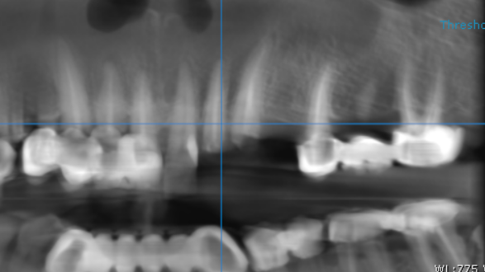

3-DIMENSIONAL VIEW

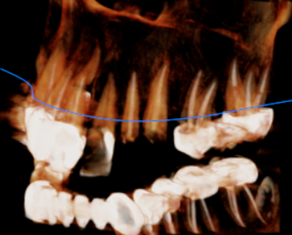

CROSS SECTIONAL VIEW

22 region | 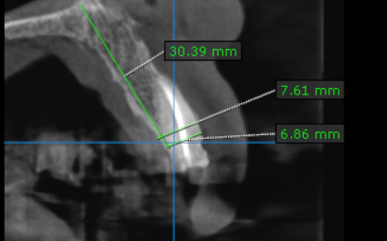
23 region | 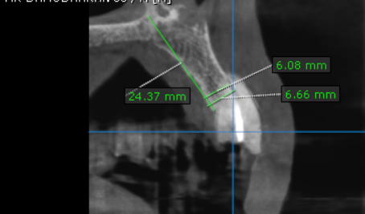
24 region | 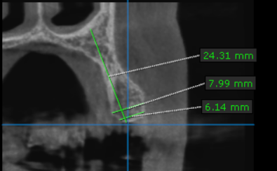

**** End of report ****

